Date |  |  | Aug - Sept
BIG IDEA |  |  | Geographic tools are used locate places, and measure and record geographic information.
(20) Social studies skills. The student applies critical-thinking skills to organize and use information acquired through established research methodologies from a variety of valid sources, including technology. The student is expected to:  (C) organize and interpret information from outlines, reports, databases, and visuals, including graphs, charts, timelines, and maps;  (21) Social studies skills. The student uses geographic tools to collect, analyze, and interpret data. The student is expected to:  (A) create and interpret thematic maps, graphs, and charts representing various aspects of Texas during the 19th, 20th, and 21st centuries; and  (B) analyze and interpret geographic distributions and patterns in Texas during the 19th, 20th, and 21st centuries.  (22) Social studies skills. The student communicates in written, oral, and visual forms. The student is expected to:  (A) use social studies terminology correctly; |  |  | Geography Concepts and Skills: REVIEW  {US-TX connection= Students will be able to use geographic concepts to analyze and compare geographic regions in Texas and the U.S. Ex: differences in land elevation, climate, precipitation, etc. between New England, Middle, and Southern Colonies, as well as differences between the four regions of Texas.}  Chapter 1 – Lesson 2  1. Locate and identify continents and oceans. (RA2-7)  2. Concept of City, County, State, Country, Continent, Hemisphere, Planet - Smallest to the largest & names of each where they live.  (Location Circle)  3. Directions – compass rose; be able to locate and label on maps.  Cardinal directions – north, south, east, and west.  Intermediate directions – northeast, northwest, southeast, and southwest.  Students should be able to use both cardinal and  intermediate directions to move from place to place on the map as well as locate places from where their location. (Examples: If you travel from Dallas to El Paso what direction have you gone? What direction is Dallas from El Paso? Fort Worth is ______ of Austin?)  4. Map Scale – Use map scale to determine distance between given locations on a map.  5. Geographic Grid – use grids with letters and numbers in them to locate places on the grid.  6. Latitude & Longitude – Coordinates (Pg.16-17)  Latitude is the measurement in degrees north or south of the equator, also called parallels. Equator is the 0 ° line of latitude that divides the earth into north and south.  Longitude is the measurement in degrees east or west of prime meridian, also called meridians. Prime Meridian is the 0° line of longitude that divides the earth into east and west.  Locate places & regions using latitude and longitude.  Absolute/Relative Location (Pg.15)  Absolute – exact/global address;  Relative – relation to other places.  Locate places important in the 19th, 20th, & 21st centuries & regions using absolute & relative location.  Types of Maps & Globes (Pg.16-17)  Reference – (political & physical/relief); thematic/special purpose – (topic, theme, spatial distribution) Students should be able to identify the different types of maps listed.
(20) Social studies skills. The student applies critical-thinking skills to organize and use information acquired through established research methodologies from a variety of valid sources, including technology. The student is expected to:  (C) organize and interpret information from outlines, reports, databases, and visuals, including graphs, charts, timelines, and maps;  (21) Social studies skills. The student uses geographic tools to collect, analyze, and interpret data. The student is expected to:  (A) create and interpret thematic maps, graphs, and charts representing various aspects of Texas during the 19th, 20th, and 21st centuries; and  (B) analyze and interpret geographic distributions and patterns in Texas during the 19th, 20th, and 21st centuries. |  |  | Charts, Tables & Graphs –create and interpret uses of:  - circle/pie graphs – show how the parts of a whole are divided, percentages; bar graphs – (horizontal & vertical axis) compare data  - line graphs – show trends over time (increasing, decreasing)  - flowcharts – show a series of activities or steps (Example: life maps)  - timelines – show the order of events  - mileage chart – shows distance between locations  - causation charts – show cause and effect relationships  - tables - categorize and organize information
(21) Social studies skills. The student uses geographic tools to collect, analyze, and interpret data. The student is expected to:  (B) analyze and interpret geographic distributions and patterns in Texas during the 19th, 20th, and 21st centuries.  (8) Geography. The student understands the  location and characteristics of places and regions of Texas. The student is expected to:  (C) analyze the effects of physical and human factors such as climate, weather, landforms, irrigation, transportation, and communication on  major events in Texas.  (9) Geography. The student understands the effects of the interaction between humans and the environment in Texas. The student is expected to:  (A) identify ways in which Texans have adapted to and modified the environment and explain the positive and negative consequences of  the modifications; and |  |  | 5 Themes (elements) of Geography (Pg.14-15)  - Location – how do I get there?  - Place – what is it like to live there?  - Human – Environment Interaction – how do the people relate to the land?  - Movement – how do people, goods, and ideas move into and out of this place?  - Regions – people bound together by physical or cultural groups.
ELPS | C2g-understand general meaning | C3b-use new vocabulary | Strategies for ELPS  *Student repeats information in own words or can complete a sentence stem  *Retelling, Summarization Frames, Structured Conversation  *Non-linguistic representation of reading, Graphic organizer  *Cloze sentences, Dialogue Journal, Read-Write-Pair-Share
 | C4i-show comprehension thru basic reading skills | C5b-write using new vocabulary
Prior Knowledge |  |  | Grades 3-6 Geography Skills
Distractor Factors |  |  | *Students often confuse or fail to differentiate between lines of longitude and lines of latitude.
RECOMMENDED Lessons |  |  |  | ADDITIONAL RESOURCES and Activities  Five Themes of Geography - PowerPoint
TECHNOLOGY INTEGRATION AND LINKS
Technology Project Lesson Plan
Technology Newsletter 1

Pre AP/GT Extensions and Projects

CONTENT SPECIFIC RESOURCES
WRITING PROMPTS:

A ________________ graph is the most useful to a historian or geographer because it ……………………….

ESSENTIAL QUESTIONS  What are the different parts of a map and how are they used?  How do map grids and longitude/latitude help geographers?  What are the different types of maps and how do they differ?  How are graphs useful to historians and geographers?  What is each type of graph used for? |  |  |  | SAMPLE TEST ITEMS  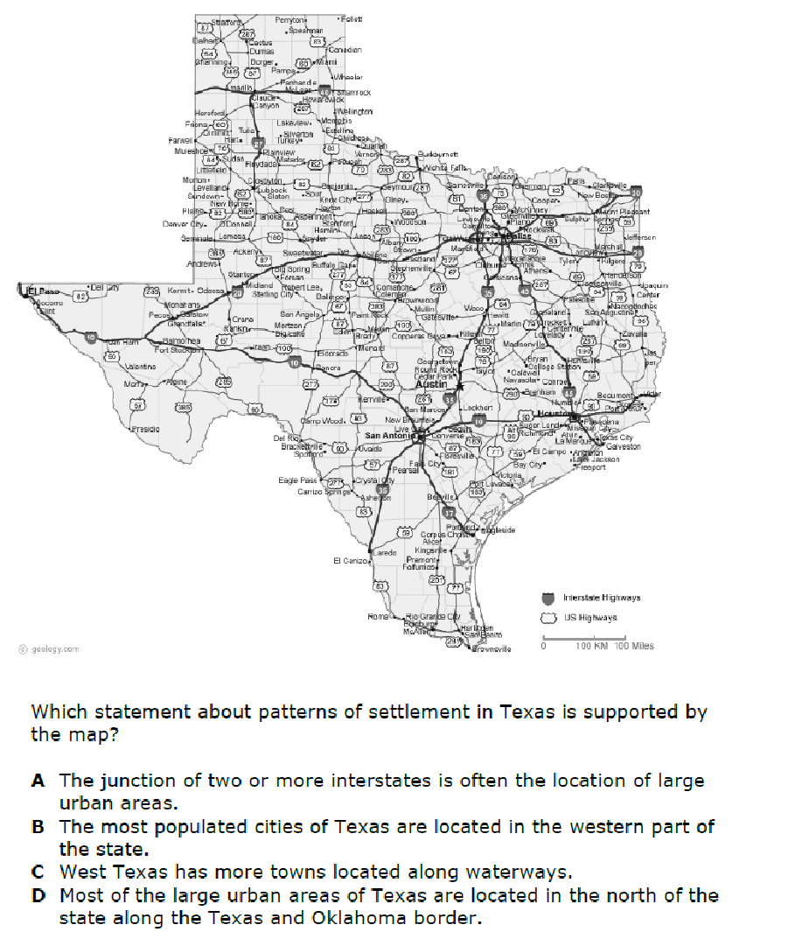
VOCABULARY relative location absolute location
cardinal directions longitude coordinates
intermediate directions latitude meridian
grid parallel

